Snapshots of the library usage

1. Creating a Task using the compiler. 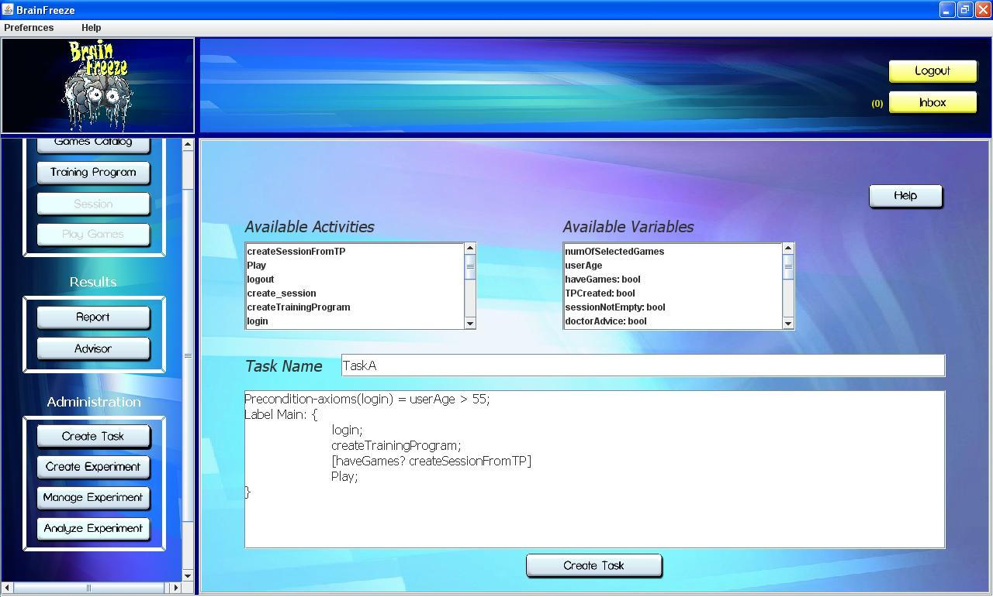
2. Creating an Experiment from Tasks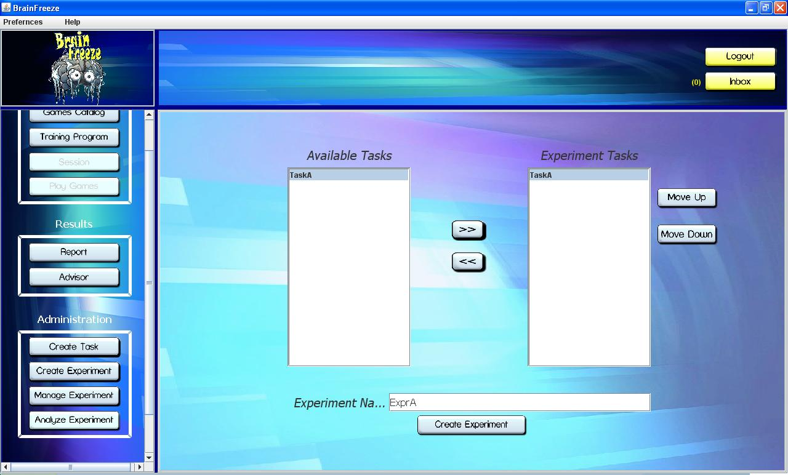
3. Enabling the Experiment

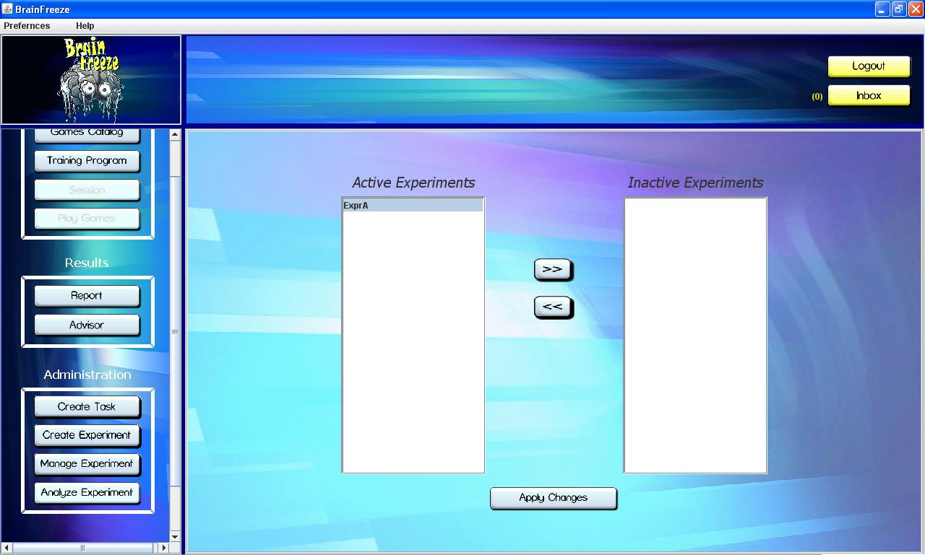

1. View the recorded data

